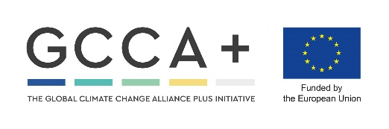

APPLICATION FORM
Research Methodology Internship (RMI) 2022
Theme: “Assessing the efficiency of climate change outreach programmes in Namibia”
Application Deadline: Friday 22nd March 2022
NB: Please attach copies of your CV, university transcript, and COVID-19 vaccination card to apply

This internship consists of three sections: 1. Intense training at Gobabeb station for three weeks (13th – 19th April); 2. Data gathering and outreach in your hometown (stated below);
3. Data analysis, discussion, conclusions, and create deliverables at Gobabeb Station for three weeks in July.
By submitting this application, you are indicating your dedicated availability for the entire duration of the internship (13th April – 27th July 2022).
This internship aims to train you in science-based knowledge on climate change, and its predicted local effects, assess the current success of climate change awareness programmes in informing the public about these issues, and create a firm database to inform decision makers for future outreach programmes.
Personal details
Surname
Name(s)
ID number
Email address
Cell phone number

Languages spoken and written

Town of residence (Where will you be doing your outreach?)

COVID-19 vaccination dates

Academic qualifications
University name
Degree name and year of graduation

Which university subject did you enjoy most and why? (20 – 50 words)

Do you have any experience organising community meetings/ activities or conducting surveys/ teaching or mentoring? (20 – 50 words)

Have you been a member of an environmental group? Where?
How are YOU a unique candidate for this opportunity? (50 – 100 words)

Do you think your community is well informed about climate change and its expected local impacts? Why? (50 – 100 words)

How would you improve climate change awareness in your community (10 – 20 words)

