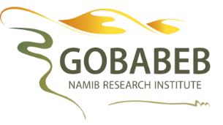
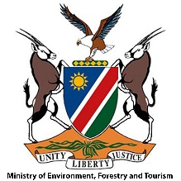
APPLICATION FORM
Climate Action for Millennials Programme (CAMP)
2021 August
Topic: “Climate, Food Security and Water”
Application Deadline: Friday 25th June 2021
NB: Please attach copies of your CV and final-year university transcript

This training course aims to develop science-based knowledge on climate change, and its predicted local effects. You will also create outreach materials for you to educate groups of secondary school learners in your home town during the third school term of 2021, under the guidance of Gobabeb.
Personal details
Surname
Name(s)
ID number
Email address
Cell phone number

Languages spoken

Town of residence (Where will you be giving your training to schools?)

Academic qualifications
Tertiary institution
Degree and Year obtained

Which university subject did you enjoy most and why? (20 – 50 words)

Which school subject did you enjoy most and why? (20 – 50 words)

Do you have any experience teaching or mentoring? (20 – 50 words)

Have you been a member of an environmental group? Which?

Why do you want to learn more about climate change? (50 – 100 words)

Do you think secondary school learners should be taught about climate change and its expected local impacts? Why? (50 – 100 words)

Tell us something interesting about yourself that is not mentioned here or on your CV. (10 – 20 words)

