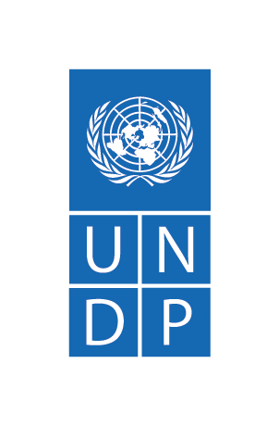
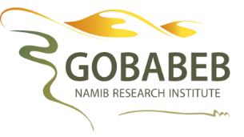
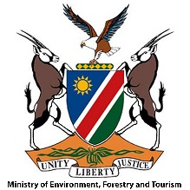
APPLICATION FORM
Climate Action for Millennials Programme (CAMP)
2022 Topic: “Climate Change and Ecosystem Health”
Application Deadline: 8th May 2022
NB: Please attach your CV, university transcript and copy of your COVID-19 vaccination book

This training course aims to develop science-based understanding of climate change,and its predicted local effects. You willalso create outreach materials to educate at least 350 community members or secondary school learners in your home-town (stated below) during the July and August 2022, under the guidance of Gobabeb.
Personal details
Surname
Name(s)
ID number
Email address
Cellphone number

Languages spoken fluently

COVID-19 vaccination dates
Town where you plan to complete your outreach

Academic qualifications
University name
Degree name and completion year

Which university subject did you enjoy most and why? (No more than 50 words)

Do you have any teaching/ mentoring experience? Where?

Have you been a member of an environmental group? Where?

Why are you a unique candidate for this opportunity?(No more than 20 words)

Does your community understand Climate Change? (No more than 50 words)

Which groups/ schools in your community are you thinking of engaging for your outreach?
Why these? (No more than 100 words)

